ACTIVITY 2.1: PARTS OF A SPIDER
S2.1A

Spiders might look a bit scary from a distance. Let’s have a closer look at the parts of their bodies.
In this activity you will find out about spiders’ body parts.

The following parts of the spider match up with the descriptions in the table.

1. Match each of the parts of a spider to the correct description.

abdomen, eyes, head region, pedipalp, leg, fang, spinneret

Description | Name of part
Spiders usually have eight of these to see with

The eyes can be found here

Leg-like mouthpart, used by the spider to feel its way

The second of the two major body parts

Structure at the back of the body, which spiders use to spin silk with

Used by the spider for support and movement

Dracula-like tooth structure used by spiders to kill prey

2. Label the diagram of the spider with the body parts. To help you with the labelling, one of the labels has been filled in.
ACTIVITY 2.1: PARTS OF A SPIDER
S2.1B

leg
abdomen
spinneret
eyes

pedipalps
head region

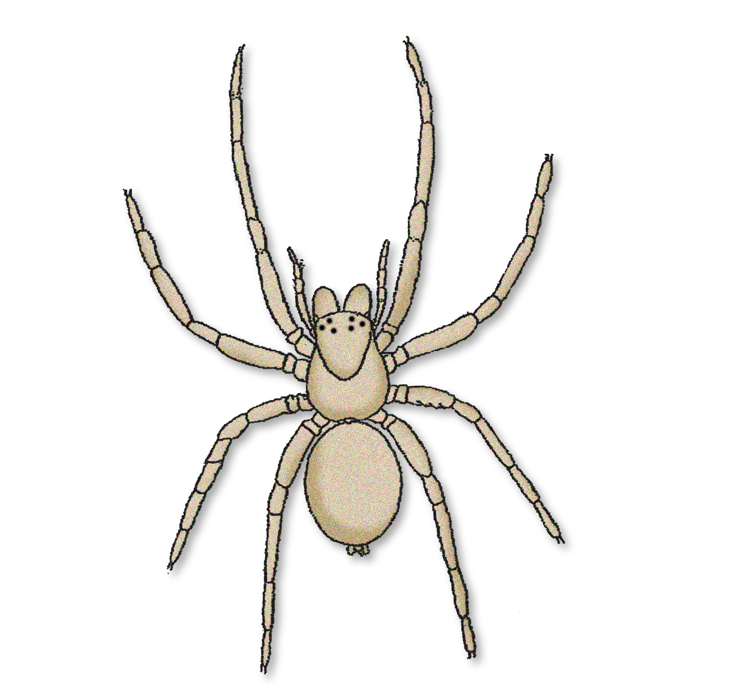
fang

.

